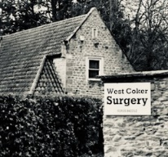

**West Coker Surgery**

**NEWSLETTER**

**September 2023**

**COVID-19 INFORMATION AUTUMN 2023**

West Coker Surgery is **not** involved in the Covid vaccination programme this year.

**For ALL enquiries regarding vaccination, treatments etc:**

**TELEPHONE 119**

**Flu vaccinations 2023 – BOOK NOW**

We will be holding flu vaccination clinics at **EAST** Coker Village Hall on Saturday 14th and Saturday 21st of October.

Either call in, telephone reception, or book online.

**SHINGLES VACCINATION**

At least 9 in 10 adults are already infected with the virus that causes Shingles, having had chickenpox as children, and around one in four people will go on to develop Shingles in their lifetime – the risk of this increases with age.

The Shingles vaccine is available to those turning 65 **OR** 70-79 yrs between 1st September 2023 and 31st August 2024.

**\*\*\*\*We are OPEN TO NEW PATIENTS who would like to register with us\*\*\*\***

Our catchment area includes not only West Coker, but also many surrounding villages.

Please contact our reception team to check if you are in catchment and want to register with us.

**The GP Patient Survey Results for 2023 have now been published**

Full details available at [www.gp-patient.co.uk](http://www.gp-patient.co.uk)

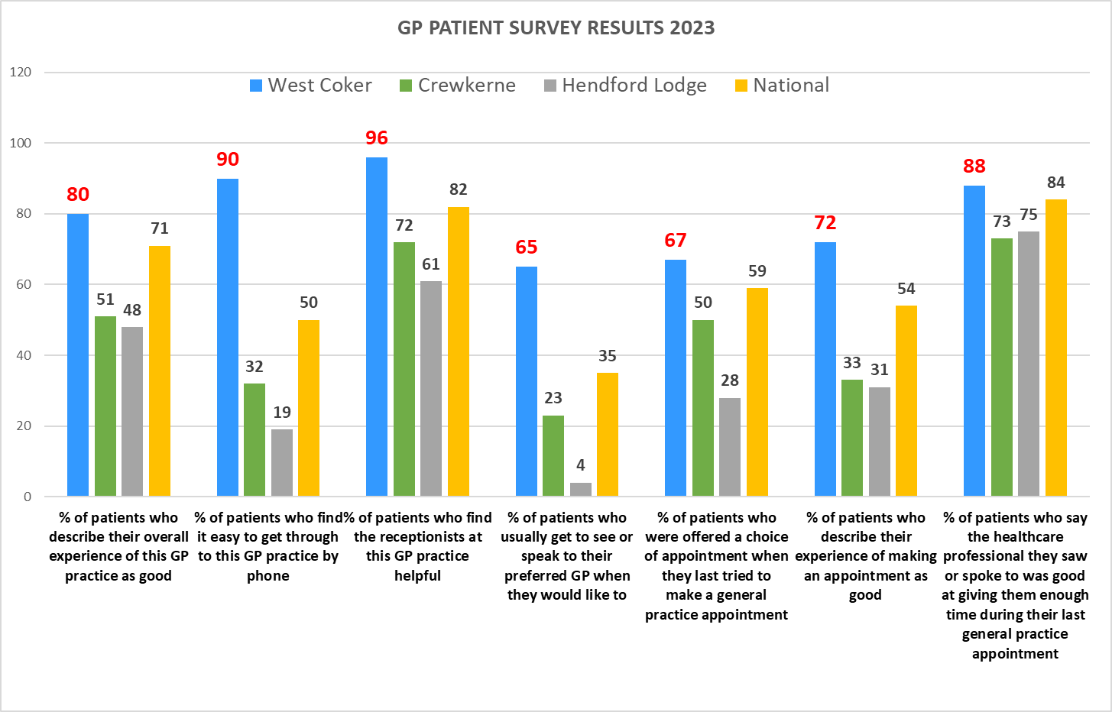

**WANT THE LATEST NHS NEWS?**

Go to: www.england.nhs.uk/news

***Or for more local news*:**

nhssomerset.nhs.uk/news-and-events/news/

**NHS guide to health conditions:** www.nhs.uk/conditions/

**Medical Student Training**

Thank you to all our patients who were happy to be seen by our supervised Medical Students over the past few months.

**HAVE WE GOT YOUR NUMBER?**

Do we have your most up-to-date mobile number? It may not be the same as when you first registered with us. With your permission, it can be useful to both you, and us, to make contact by telephone or text for things such as appointment reminders, notifications of vaccination clinics etc.

**Staff Training 2023:**

The surgery holds staff training sessions on the 3rd Thursday of every month between 1 – 3pm (this may periodically vary).

During these times, ***for urgent calls only***, there will be a diversion of the surgery telephone which will be answered. We ask that you try not to call at the surgery, or telephone during this 2-hour period; the surgery will be physically closed.

**Training dates** Thurs 21st **Sept** Thurs 19th **Oct** Thurs 16th **Nov**

Thurs 14th **Dec**

**MINOR INJURY UNITS**

There are a total of 7 MIUs across Somerset, offering **same day urgent care** for conditions such as:

Soft tissue injuries Broken bones

Injuries & wounds Minor head injuries

Soft tissue infections & bites Chest infections

Emergency contraception Throat infections

Eye injuries & infections Urinary infections

The nearest MIU is at **Chard Community Hospital,**

Crewkerne Rd, Chard T20 1NF Tel: 01460 238220

Open 7 days a week from 8am to 9pm.

Note: x-ray facilities are not available until October 2023 due to an equipment upgrade.

**Useful Information**

[**www.111.nhs.uk**](http://www.111.nhs.uk)

[**www.nhs.uk**](http://www.nhs.uk) **–** guides to conditions, symptoms, treatments, medicines (how they work, side-effects etc.).

**Download App:** HANDi Paediatric.

**Yeovil Hospital**:

01935 475122

**Musgrove Park Hospital:**

01823 333444

**Physiotherapy**:

01935 384358 or

01935 384510 (very busy - you may need to try several times).

**Mindline:**

**We welcome our new Practice Nurses**

We are delighted that **Vicky Biscoe** has joined our team as our new Lead Practice Nurse. Vicky has a wealth of experience having formerly nursed in the Army and as Practice Nurse at Langport Surgery.

We also welcome **Becky Davis**. Becky is a Nursing Associate and will soon complete her training to become a Registered Nurse.

Vicky and Becky previously worked together and alongside Kim and Jo (our HCAs), we now have a full, highly experienced, and professional nursing team.

***Contact Information***

**Telephone:** 01935 862212 **Dispensary:** 01935 865104

**Address:** High Street, West Coker, Yeovil BA22 9AH - telephone between 12 and 3pm **only**

**Email:** somicb.westcokersurgery@nhs.net **Website:** www.westcokersurgery.nhs.uk **Out of Hours:** 111